**Review Worksheet: Neurons Name:** …………………………………………………

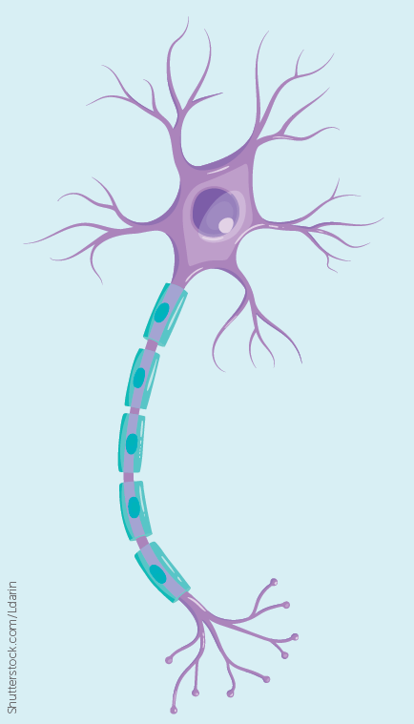*Do these questions, using your learning resources. Look at the “marks” to give you an idea of the level of detail required in the response (formative only – does not count towards your grade). At the end, mark your work, correct it, and fill in the reflection section. Questions marked * require you to use reasoning, inferring and application of knowledge, or perhaps extra research to get the answer. It won’t be right there in the text.*

1: Label the diagram to identify the axon, cell body, myelin sheath, dendrite, nucleus, axon terminal, cytoplasm, node of Ranvier, and Schwann cell.

(4.5 marks)

2: Complete the table to state the function of each part of the neuron

(2.5 marks)

|  |  |
| --- | --- |
| **Structure** | **Function** |
| Mitochondria |  |
| Axon |  |
| Dendrite |  |
| Myelin Sheath |  |
| Neurilemma |  |

3: State the function of:

(3 marks)

Motor Neurons …………………………………………………………………………..

Interneurons……………………………………………………………………………..

Sensory Neurons………………………………………………………………………..

4: What structural type are sensory neurons?

(1 mark)

…………………………………………………………………………………………………………………..

5: What functional types of neurons are usually multipolar?

(1 mark)

……………………………………………………………………………………………………………………

6: Where would interneurons be found?

(2 marks)

…………………………………………………………………………………………………………………….

…………………………………………………………………………………………………………………….

7: Classify the neuron shown below and justify your choice by describing the structural features that led you to your classification.

(3 marks)

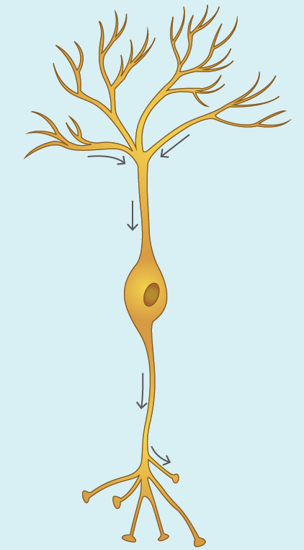

……………………………………………………………………………..

……………………………………………………………………………..

……………………………………………………………………………..

……………………………………………………………………………..

……………………………………………………………………………..

……………………………………………………………………………..

……………………………………………………………………………..

……………………………………………………………………………..

……………………………………………………………………………..

8: Are nerves and neurons the same thing? Explain your answer.

(4 marks)

…………………………………………………………………………………………………………………

………………………………………………………………………………………………………………….

………………………………………………………………………………………………………………….

………………………………………………………………………………………………………………….

9: Mixed nerves are:

(1 mark)

A: Nerves where impulses travel both up and down each neuron

B: Nerves that contain bundles of both sensory and motor fibres

C: Nerves that contain only pseudo-unipolar neurons

D: Not found in humans

10: Define “synapse” and state the function of the synapse.

(6 marks)

…………………………………………………………………………………………………………………..

…………………………………………………………………………………………………………………..

…………………………………………………………………………………………………………………..

…………………………………………………………………………………………………………………..

…………………………………………………………………………………………………………………..

…………………………………………………………………………………………………………………..

…………………………………………………………………………………………………………………..

…………………………………………………………………………………………………………………..

11: Why is the white matter in the brain white in colour? *

(2 marks)

…………………………………………………………………………………………………………………..

…………………………………………………………………………………………………………………..

…………………………………………………………………………………………………………………..

Go back and mark your work using the marking key provided. What score did you get? /30

*I included enough detail in my answers.*



*I was able to find information in the text/powerpoint presentation.*

*I was able to reason and infer where the information wasn’t directly in the text (questions with *).*

*I marked my work and wrote down any answers where I missed marks.*